WEEK-3_COGNIZANT:-
ASP.NET Core 8.0 Web API
CODE:-
AuthController.cs:-
using Microsoft.AspNetCore.Authorization;
using Microsoft.AspNetCore.Mvc;
using Microsoft.IdentityModel.Tokens;
using System.IdentityModel.Tokens.Jwt;
using System.Security.Claims;
using System.Text;
namespace EmployeeAPI.Controllers;
[ApiController]
[Route("api/[controller]")]
[AllowAnonymous]
public class AuthController : ControllerBase
{
[HttpGet]
public IActionResult Login()
{
string token =
GenerateJSONWebToken(
1,
"Admin");
return Ok(token);
}
private string GenerateJSONWebToken(
int userId,
string userRole)
{
var securityKey =
new SymmetricSecurityKey(
Encoding.UTF8.GetBytes(
"mysuperdupersecretkey12345678901"));
var credentials =
new SigningCredentials(
securityKey,
SecurityAlgorithms.HmacSha256);
var claims =
new List<Claim>
{
new Claim(
ClaimTypes.Role,
userRole)
new Claim(
"UserId",
userId.ToString())
};
var token =
new JwtSecurityToken(
issuer: "mySystem",
audience: "myUsers",
claims: claims,
expires:
//DateTime.Now.AddMinutes(10),
DateTime.Now.AddMinutes(2),
signingCredentials:
credentials);
return
new JwtSecurityTokenHandler()
.WriteToken(token);
}
}
EmployeeController.cs:-
using EmployeeAPI.Models;
using Microsoft.AspNetCore.Authorization;
using Microsoft.AspNetCore.Mvc;
using EmployeeAPI.Filters;
namespace EmployeeAPI.Controllers;
[ApiController]
[Route("api/[controller]")]
//[CustomAuthFilter]
//[Authorize(Roles = "POC")]
[Authorize(Roles = "Admin,POC")]
public class EmployeeController : ControllerBase
{
private readonly List<Employee> employees;
public EmployeeController()
{
employees = GetStandardEmployeeList();

private List<Employee> GetStandardEmployeeList()
{
return
[
new Employee
{
Id = 1,
Name = "John",
Salary = 50000,
Permanent = true,
DateOfBirth = new DateTime(1998,5,12),
Department = new Department
{
Id = 101,
Name = "IT"
},
Skills =
[
new Skill
{
Id = 1,
Name = "C#"
},
new Skill
{
Id = 2,
Name = "SQL"
}
]
},
new Employee
{ Id = 2,
Name = "Alice",
Salary = 60000,
Permanent = false,
DateOfBirth = new DateTime(1997,2,20),
Department = new Department
{
Id = 102,
Name = "HR"
}
Skills =
[
new Skill
{ Id = 3,
Name = "Communication"
} ]
} ]; }
[HttpGet]
//[AllowAnonymous]
[ProducesResponseType(
StatusCodes.Status200OK)]
public ActionResult<List<Employee>> GetStandard()
{
return Ok(employees);
}
//[HttpGet]
//[ProducesResponseType(
//StatusCodes.Status500InternalServerError)
//public ActionResult<List<Employee>>
//GetStandard()
//{
// throw new Exception("Demo Exception");
//}
[HttpPost]
public IActionResult AddEmployee(
[FromBody] Employee employee)
{
employees.Add(employee);
return Ok(employee);
}
[HttpPut("{id}")]
[ProducesResponseType(StatusCodes.Status200OK)]
[ProducesResponseType(StatusCodes.Status400BadRequest)]
public ActionResult<Employee> UpdateEmployee(
int id,
[FromBody] Employee employee)
{
// Check for invalid id
if (id <= 0)
{
return BadRequest("Invalid employee id");
}
// Find employee
Employee? existingEmployee =
employees.FirstOrDefault(e => e.Id == id);
// Employee not found
if (existingEmployee == null)
{
return BadRequest("Invalid employee id");
}
// Update employee
existingEmployee.Name = employee.Name;
existingEmployee.Salary = employee.Salary;
existingEmployee.Permanent = employee.Permanent;
existingEmployee.Department = employee.Department;
existingEmployee.Skills = employee.Skills;
existingEmployee.DateOfBirth = employee.DateOfBirth;
// Return updated employee
return Ok(existingEmployee);
}
}
ValuesController.cs:-
using Microsoft.AspNetCore.Mvc;
namespace FirstWebAPI.Controllers;
[ApiController]
[Route("api/[controller]")]
public class ValuesController : ControllerBase
{
[HttpGet]
public IActionResult Get()
{ return Ok(new[]
{ "Value 1", "Value 2", "Value 3"
});
}
[HttpPost]
public IActionResult Post(string value)
{ return Ok($"Received: {value}");
}
[HttpPut("{id}")]
public IActionResult Put(int id, string value)
{return Ok($"Updated {id} with {value}");
}
[HttpDelete("{id}")]
public IActionResult Delete(int id)
{return Ok($"Deleted {id}");
}}

Filters:-
CustomAuthFilter.cs:-
using Microsoft.AspNetCore.Mvc;
using Microsoft.AspNetCore.Mvc.Filters;
namespace EmployeeAPI.Filters;
public class CustomAuthFilter : ActionFilterAttribute
{ public override void OnActionExecuting(
ActionExecutingContext context)
{
if (!context.HttpContext.Request.Headers
.ContainsKey("Authorization"))
{ context.Result =
new BadRequestObjectResult(
"Invalid request - No Auth token");
return;
}
string? token =
context.HttpContext.Request
.Headers["Authorization"];
if (!token.Contains("Bearer"))
{ context.Result =
new BadRequestObjectResult(
"Invalid request - Token present but Bearer unavailable");
}
}
}
CustomExceptionFilter.cs:-
using Microsoft.AspNetCore.Mvc;
using Microsoft.AspNetCore.Mvc.Filters;
namespace EmployeeAPI.Filters;
public class CustomExceptionFilter
: IExceptionFilter
{
public void OnException(
ExceptionContext context)
{
File.AppendAllText(
"errors.txt",
$"{DateTime.Now}\n" +
$"{context.Exception}\n\n");
context.Result =
new ObjectResult(
"Internal Server Error")
{
StatusCode = 500
};
context.ExceptionHandled = true;
}
}
Models:-
Department.cs:-
namespace EmployeeAPI.Models;
public class Department
{
public int Id { get; set; }
public string Name { get; set; } = string.Empty;
}

Employee.cs:-
namespace EmployeeAPI.Models;
public class Employee
{
public int Id { get; set; }
public string Name { get; set; } = string.Empty;
public int Salary { get; set; }
public bool Permanent { get; set; }
public Department? Department { get; set; }
public List<Skill> Skills { get; set; } = [];
public DateTime DateOfBirth { get; set; }
}

Skill.cs:-
namespace EmployeeAPI.Models;
public class Skill
{
public int Id { get; set; }
public string Name { get; set; } = string.Empty;
}

Program.cs:-
using EmployeeAPI.Filters;
using Microsoft.AspNetCore.Authentication.JwtBearer;
using Microsoft.IdentityModel.Tokens;
using System.Text;
var builder = WebApplication.CreateBuilder(args);
// Add services to the container
// Learn more about configuring Swagger/OpenAPI at https://aka.ms/aspnetcore/swashbuckle
builder.Services.AddEndpointsApiExplorer();
builder.Services.AddSwaggerGen();
builder.Services.AddControllers(options =>
{
options.Filters.Add<CustomExceptionFilter>();
});
builder.Services.AddCors(options =>
{
options.AddPolicy("AllowReact", policy =>
{
policy
.WithOrigins("http://localhost:3000")
.AllowAnyHeader()
.AllowAnyMethod();
});
});
var key = Encoding.UTF8.GetBytes("mysuperdupersecretkey12345678901");
builder.Services
.AddAuthentication(JwtBearerDefaults.AuthenticationScheme)
.AddJwtBearer(options =>
{
options.TokenValidationParameters =
new TokenValidationParameters
{
ValidateIssuer = true,
ValidateAudience = true,
ValidateLifetime = true,
ValidateIssuerSigningKey = true,
ValidIssuer = "mySystem",
ValidAudience = "myUsers",
IssuerSigningKey =
new SymmetricSecurityKey(key)
};
});
var app = builder.Build();
// Configure the HTTP request pipeline.
if (app.Environment.IsDevelopment())
{
app.UseSwagger();
app.UseSwaggerUI();
}
app.UseCors("AllowReact");
app.UseHttpsRedirection();
app.UseAuthentication();
app.UseAuthorization();
app.MapControllers();
app.Run();

OUTPUT_1:-
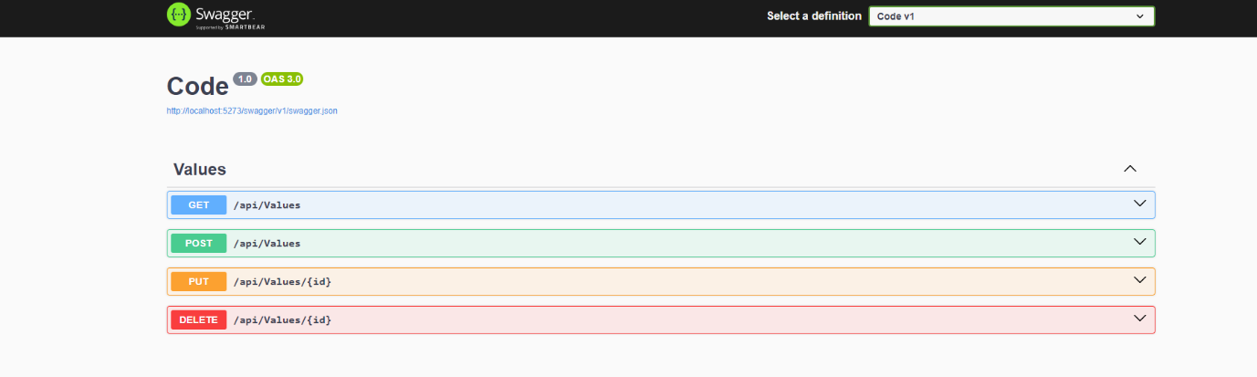
OUTPUT_2:-
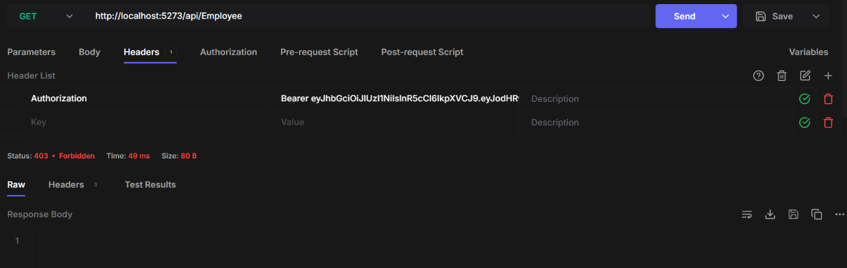
OUTPUT_3:-
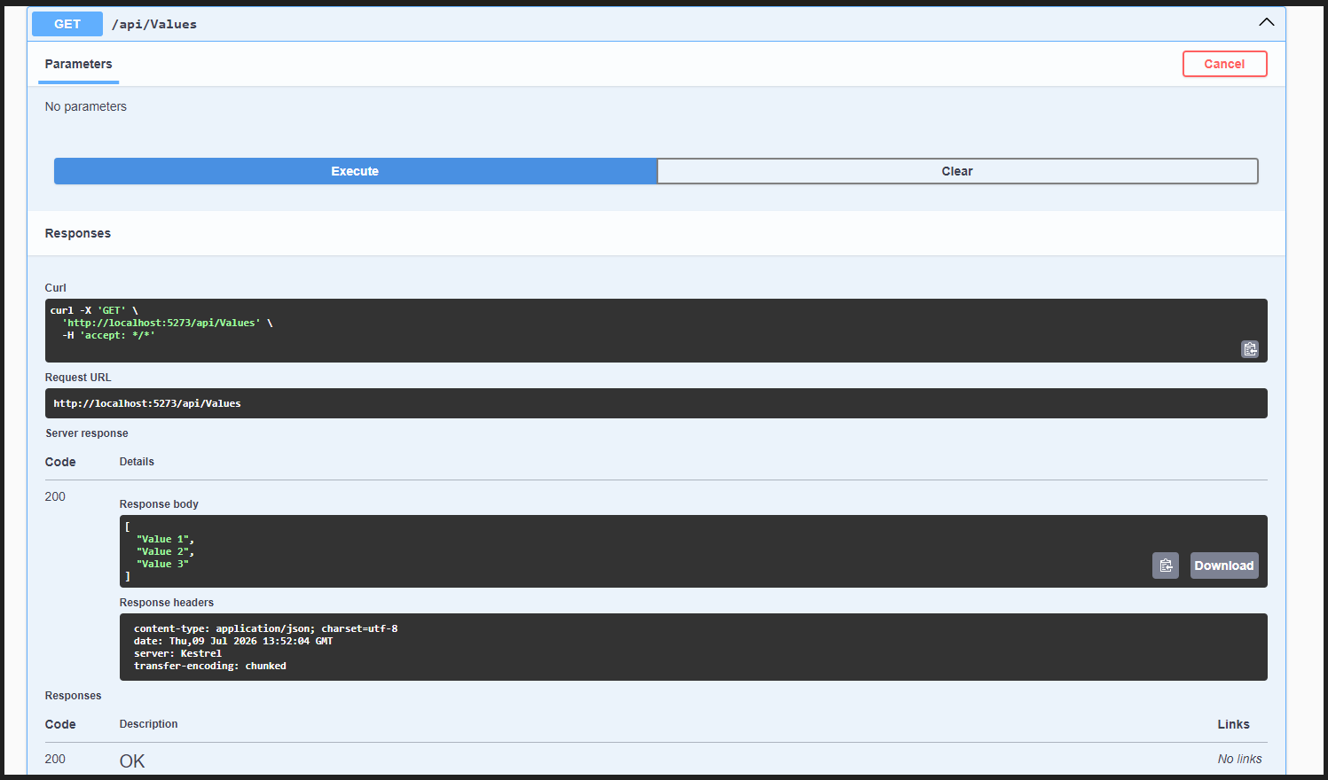

OUTPUT_4:-
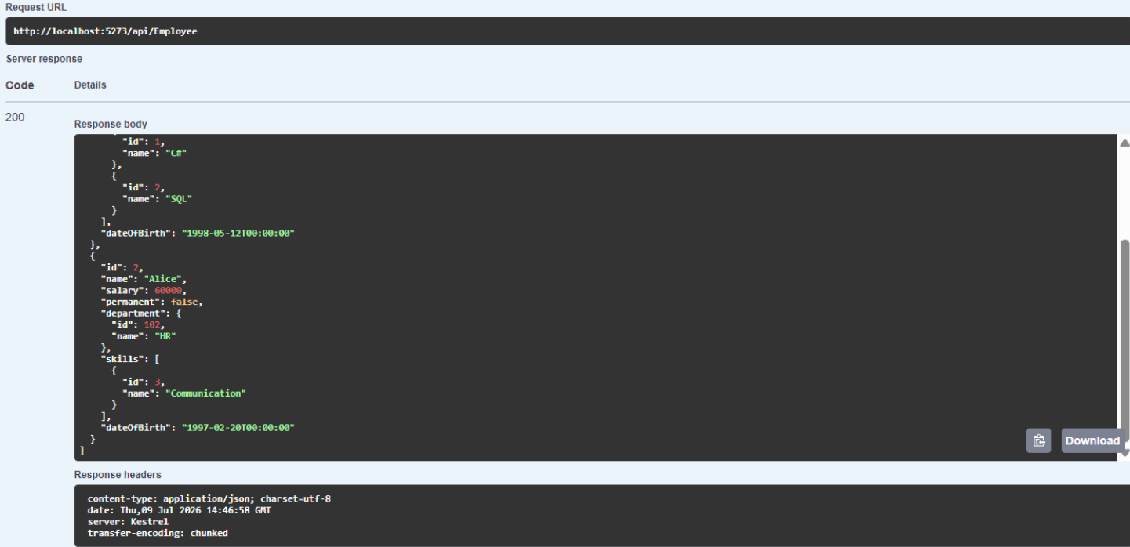
OUTPUT_5:-
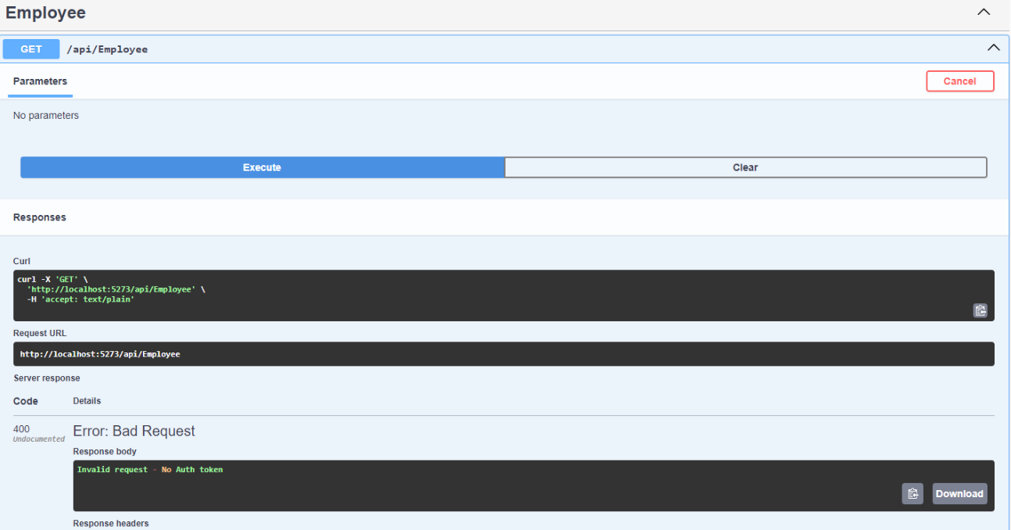
OUTPUT_6:-
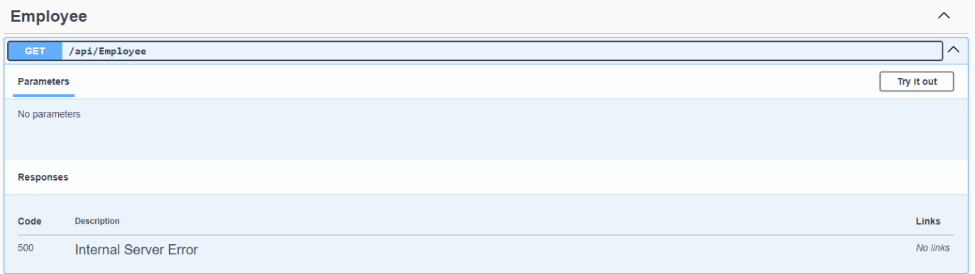
OUTPUT_7:-
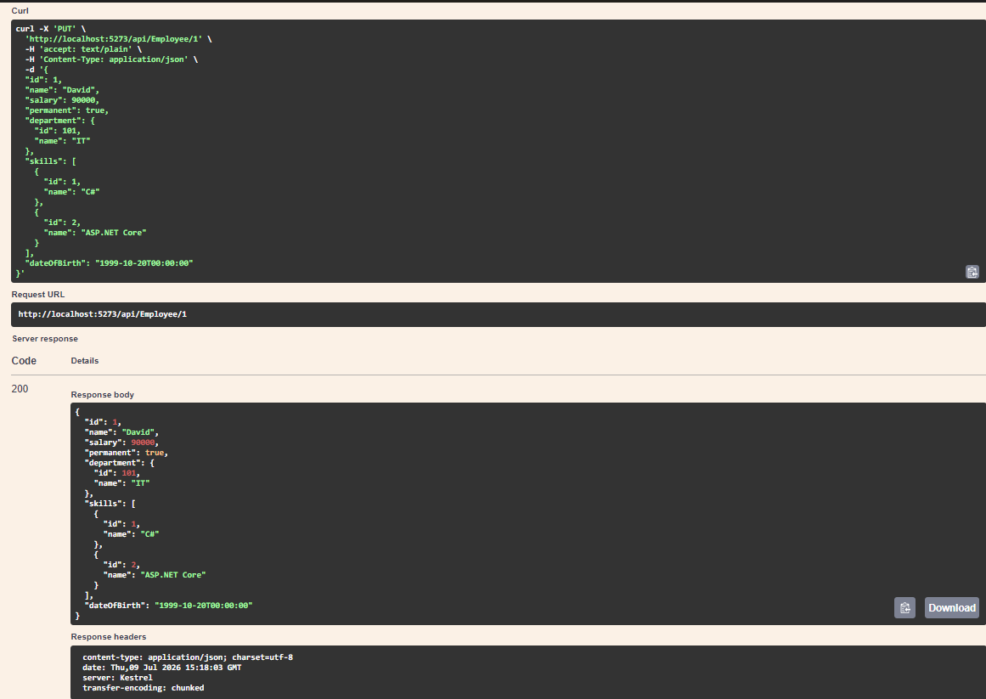
OUTPUT_8:-
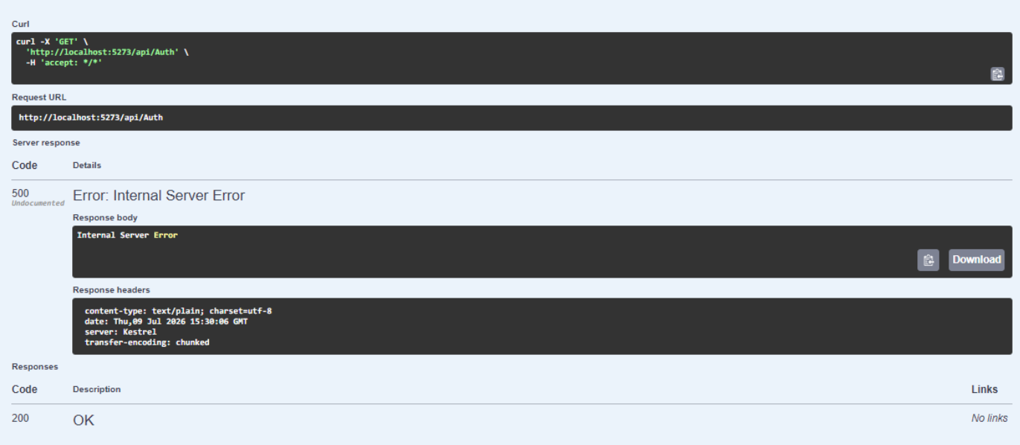
OUTPUT_9:-
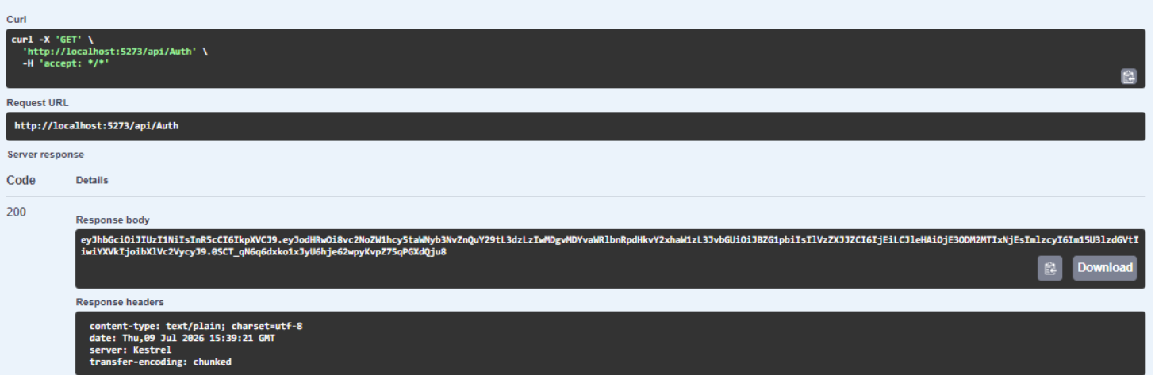
OUTPUT_10:-
